**Common lab solutions**

**Phosphate buffered saline (PBS)**

<https://www.aatbio.com/resources/buffer-preparations-and-recipes/pbs-phosphate-buffered-saline>

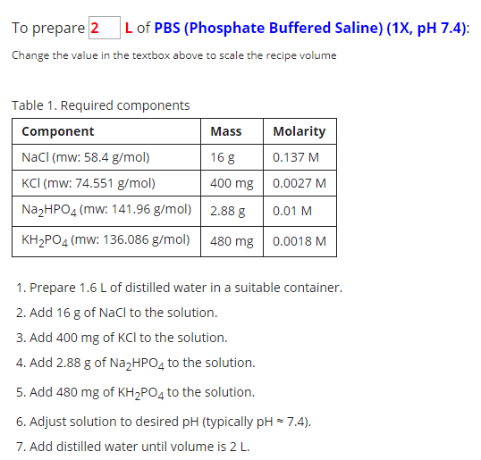

**PB (phosphate buffer) 100mL**

1.93g sodium phosphate dibasic  
0.77g sodium phosphate monobasic  
1. Add monobasic and dibasic to volumetric flask  
2. Fill to 100mL with ddH2O  
3. Stir until dissolved, store in 4C fridge

**Gelatin-coated slides**

Gelatin solution (1L):

1. Dissolve 5g gelatin in about 500ml ddH2O. Stir and heat up to 50C
2. Cool to RT
3. Add 0.5g CrK(SO4)2 (chromium potassium sulfate)
4. Remove stir bar and fill to 1000ml with ddH2O
5. Store in 4C. Can be reused – vacuum filtrate before reusing.

Slide prep:

1. Wash slides in soap and water, rinse well.
2. Rinse slides in 70% ethanol and dry completely with Kimwipes so there are no streaks
3. Place slides in metal slide rack without touching surface
4. Dip rack in gelatin solution 3x for 5sec
5. Let rack dry under paper towels overnight

**DAPI (100mL)**

1mg bisBenzimide  
**wear gloves!!

1. Add bisBenzimide to volumetric flask
2. Fill to 100mL with ddH2O
3. Stir until dissolved
4. Wrap flask in foil to protect from light and store in 4C fridge

**Sucrose 30% (100mL)**

1. Add 30g sucrose to volumetric flask
2. Fill to 100mL with PB
3. Stir until dissolved, store in 4C fridge
4. For cryoprotection, sink fixed tissue at least overnight or until tissue block sinks